Basic Show Goat Information

Barns and/or Sheds

Goats need a combination arrangement: access to a shed and an area where they can get away from or

in the sunshine. The shed area should have at least 15 square feet of space for each goat. Generally, the

pen should be at least 4 feet by 6 feet. The outside pen needs to be as big as possible to allow the goat to

exercise. Some youth have a jump between the feed and water to develop muscle in the goats. The shed

should be well-drained so water does not accumulate under the barn. Sheds or barns normally, but not

always, should open to the east or south. Barn temperature is critical. Structures should be well

ventilated so goats will remain cool and continue to grow during the summer months.

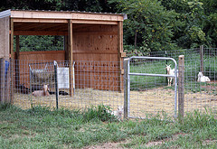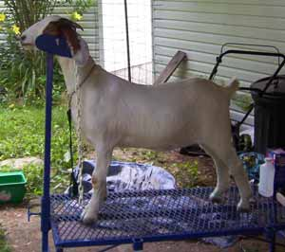

Pen Fences

Fence height should be at least 42 inches tall, preferably 48 inches tall, to keep goats from attempting to

jump and should be predator-proof. If you are using net wire fences, 12-inch mesh should be used rather

than 6-inch mesh to keep goats from getting heir heads hung. However, the most desirable pens

are constructed from galvanized livestock panels that are 5 feet tall with 4-inch squares.

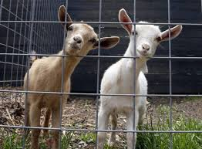

Feeders

Self-feeders are often used in the feeding of club goats. Self-feeders for market goats of more than

30 pounds should be blocked up at least 16 inches off the ground, preferably higher, to keep feces out of

the trough. It is usually best to feed the goats on a ramp to aid in developing leg muscles. Ramps should

not be used if rectal prolapses are a problem. Hand feeding of goats should be done in movable troughs

which hang on the fence at the appropriate height. Troughs should be hung at the same height as the top

of the shoulder of the goats being fed, if not fed on a ramp. These movable troughs need to be taken down

and cleaned regularly. Leads with a snap can be used to separate goats wearing halters. Likewise, hay and

mineral feeders need to be raised off the ground. This will help reduce the spread of disease, especially

internal parasites. It is also important to make sure goats are unable to stand in their feed trough as they

will urinate or defecate on the feed.

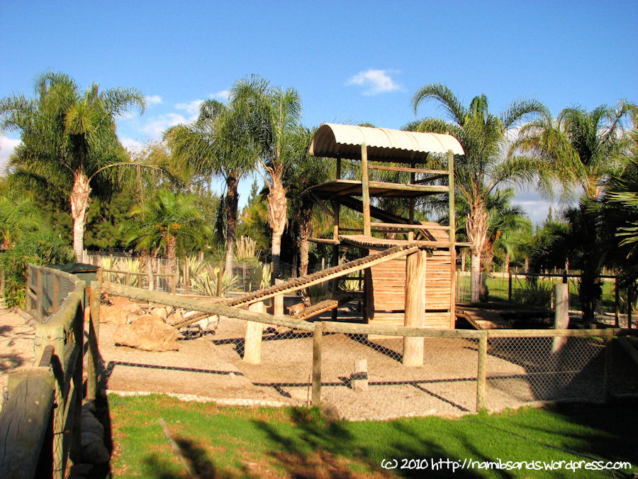

Water Containers

Clean water is the most important ingredient for feeding club goats. Goats should not be allowed to

defecate in the water, and the water should not be a source of disease. Water troughs should be small so

they can be drained and cleaned on a regular basis. Remember that water troughs should be checked on a

daily basis. Water troughs should be located in the shade to keep water cool. However, in the hot summer

months, some goats tend to drink too much water and appear “full.” Water should never be totally

removed for the goat, but rationing water prior to a show will help remove the belly from the goat and

increase the goat’s chances in the show ring. Remember, do not dehydrate your goat. The proper amount

of fluids is vital to the feel and condition of your goat.

Necessary Equipment

The following list of equipment is considered necessary for feeding and exhibiting club goats. You

may share some of the equipment with other members of your club, chapter or team. In most cases, it is

better to share equipment to see how you like it before investing in equipment.

• Shovel or rake to clean pens occasionally

• Scales to weigh goats (Bath scales work.)

• Trimming table with the following dimensions: 45" x 20" x 18" tall

• Hoof trimmers

• Electric clippers are necessary but can vary. Options include: 1) classic sheep and goat

clippers with 20- and 23-tooth combs and 4-point cutters, an all-purpose blade (close to the skin) and

plucking blade (leaves 3/8"),

2) small animal grooming clippers with detachable blades for varying lengths of hair,

3) newer model lightweight clippers with blades for both fine and medium cuts and/or

4) classic cattle clippers with surgical and medium blades. Many exhibitors elect to spend more money

for the newer lightweight clippers that have less vibration and closer teeth so youth can use the clippers

more easily and with greater safety.

• Syringes and needles for injections

• Goat blankets and/or socks

• Halters, collars and/or show chains

• Some medical supplies

Optional Equipment

The following additional equipment is often acquired by families who feed several goats and

exhibit goats at several major shows. The equipment might be shared by a group of 4-H or FFA members.

• Show box to hold equipment

• Hot air blower or dryer

• Portable livestock scales

• Extension cords

• Electric fans

